

**Foreign Mothers Meetup**

This group is for foreign mothers (including pregnant women) living in Oshu.

When？　Feb. 27th (Tues) 10 AM – 11:45 AM

Where？　Central Child-rearing Support Center (Izumi Nursery School)

　☎　　 Mizusawa Health Center (℡ 23-4511)

**February 2018**

**Oshu City Newsletter**

**Sunday/Holiday Doctors**

|  |  |  |  |  |  |  |  |  |
| --- | --- | --- | --- | --- | --- | --- | --- | --- |
| **Mizusawa Ward** | | | | | | | | |
| Day | | |  | | | ☎ | | Address |
| Open Sundays, holidays 8:30 am - 4:00 pm. Open nights every day 6:30 pm - 9:00 pm. | | | Oshu Kanegasaki Holidays Clinic | | | 25-3935 | | 21-1 Taga Mizusawa |
| **Esashi Ward (Mornings, check times in advance by phone)** | | | | | | | | |
| Day | |  | | | ☎ | | Address | |
| Feb. 4th | | Kashiwaki Clinic | | | 35-2433 | | 5-7 Muikamachi | |
| 11th | | Oinao Ob-Gyn Clinic | | | 34-3033 | | 11 Iwayado Aza Kozakai | |
| 12th | | Sekiya Clinic | | | 35-3511 | | 5-20 Odori | |
| 18th | | Takahashi Int. Med. Clinic | | | 35-6668 | | 1-30 Odori | |
| 25th | | Takita Clinic | | | 35-2315 | | 1-9 Muikamachi | |
| **Dentists (9:00 – 12:00)** | | | | | | | | |
| Day |  | | | ☎ | | Address | | |
| Feb. 4th | Kita Odori Dental Clinic | | | 51-9293 | | 27-2 Aza Kitaushizawa, Mizusawa | | |
| 11th | Takano Dental Clinic | | | 23-2488 | | 37-7 Aza Yachimyoen, Mizusawa | | |
| 18th | Natsuta Dental Clinic | | | 46-4710 | | 164-1 Aza Unada Natsuta, Isawa | | |
| 25th | Maeda Dental Clinic | | | 36-9100 | | 1-3-1 Toyota-cho, Esashi | | |
| ★Children Emergency Helpline (☎ 019-605-9000) Open daily 7 PM-11 PM | | | | | | | | |

**Lock Your Doors to Prevent Burglary!**

Last year, there were 20 house burglaries in Oshu. In most of these cases, the doors were left unlocked. Leaving doors unlocked is very dangerous because if a burglar enters a house and meets someone inside, they could end up robbing or even killing that person.

When it takes too much time to open a door, burglars give up on that house. Please keep in mind the risk of leaving your doors unlocked. When you leave your house and when you sleep at night, always lock your doors to protect yourself and your belongings.

　☎　　Oshu City Crime Prevention Association (Main City Hall, inside Citizen’s Environment Department 24-2111 ext. 211)

**Free Law Consultation** Make appointment at Citizen Services Division. If you want to consult in a foreign language, please bring someone who can interpret for you. The lawyer can’t answer questions about status of residence (visas), but can about marriage, other issues.

|  |  |
| --- | --- |
| Place | Time & Date |
| Main City Hall, Gen. Consultation Room | Feb. 14th (Wed) 10:00 AM to 4:00 PM |
| Esashi Gen. Branch Office, Resident Consultation Room | Feb. 27th (Tues) 10:00 AM to 4:00 PM |

**Taxes**

National health insurance (payment #8) is due by Wednesday, February 28th.

　☎　 Tax Payment Division, Main City Hall (℡ 24-2111 ext. 341)

Produced/translated by Oshu City ILC Promotion Division

**Events**

**Oshu Mizusawa Kukuri-hina Festival**

Kuri-hina dolls (a local traditional doll made with paper and stuffed fabric) on display in 15 places within Mizusawa.

When? Wednesday, February 28th to Sunday, March 4th from 10:00 AM to 5 PM (to 4 PM on final day)

Where? Locations include Maple 4th floor main hall, Warrior Residence Museum, Machinaka Exchange Hall, Mizusawa Tourist Products Center (make your own kukuri-hina activity, reservation needed), JR Mizusawa Station, Minco Minca.

　☎　 Oshu Mizusawa Kukuri-hina Festival Executive Committee (inside Oshu Sightseeing and Products Association, 22-7800)

**Kokuseki-ji Temple Sominsai (“Naked Festival”)**

A festival of manhood, fire and (partial) nudity with more than 1,000 years of history. The participants pray for a good harvest and safety from disaster in this precious ritual carried on from ancient times. Hadaka-mairi (naked worship), scramble for the somin-bukuro, more.

When? Thursday, February 22nd 10 PM to early next morning

Where? Kokuseki-ji Temple

　☎　 Main City Hall, Commerce & Sightseeing Div. (24-2111, ext. 272, 273)

**29th Nohadate no Tsudoi**

A festival representative of Isawa’s rice culture that reenacts old rituals to pray for a good harvest and protection from harm for the lunar new year.

Pine torch burning, planting ceremony reenactment, dance by “unlucky age” adults, fireworks, and more.

When? Saturday, February 10th, 3 PM – around 8 PM

Where? Isawa Baseball Field, Event Field

　☎　 Isawa Gen. Branch Office, Industry Prom. Div. (46-2111, ext. 142, 146)

**Marvels of Snow Festival**

Treasure hunt for children, playing in the snow (slide, curling, etc), musical performance, Christmas lights, star gazing, and more.

When? Saturday, February 10th, 1:30 PM to 7:00 PM

Where? Oshu Space & Astronomy Museum, National Mizusawa VLBI Astronomical Observatory

　☎　 Oshu Space & Astronomy Museum (24-2020)

Produced/translated by Oshu City ILC Promotion Division

**Sports/Exercise Classes**

**Oshu Resident Athletic Festival Tug of War Contest**

Compete in teams of up to 12 people, with 8 people on the field at a time. Team/competition types: ① Men ② Women ③ Coed (must have 4 or more women, OK to also participate in ①or ② teams) ④ Kids (elem. school students)

When? Sunday, February 18th starting at 9:30 AM

Where? Esashi West Gymnasium

Who can join For ①②and ③, people who live or work in Oshu. For ④, children who live in Oshu. Coach must be a parent/guardian or teacher.

How to Apply Submit application (form available online) by faxing or submitting paper application

※Application deadline Wednesday, February 7th

☎ Applications Esashi General Branch Office, Lifelong Learning and Sports Division (℡ 35-2111 ext. 336, Fax 35-7466), Esashi Central Gymnasium (Fax 35-5311).

☎ Inquiries Oshu Tug of War Contest Association Office (Obara, ℡ 36-2501)

**Bowling Class for Health**

Try bowling with us! You can start bowling at any age and any level.

When? 〇Thursday class: Every Thursday from February 15 to March 22nd, 6 times total

〇Friday class: Every Friday from February 16th to March 23rd, 6 times total

Each class has a morning course starting at 9:30 AM and an afternoon class starting at 1:30 PM.

Where? Bowling Qualia in Mizusawa Ward

Cost 2000 yen (includes fees for 6 games, shoe rental, teaching materials, insurance)

# People Up to 48 people/course

☎ Questions, Applications Bowling for Health “Kenko Bolingu Kyoshitu” (Chiba, ℡ 090-7075-5222)

**Do You Need to Submit a Tax Return?**

Check if you need to submit a tax return for your income or for municipal/prefectural tax (nat’l health insurance payment) See January Oshu public relations magazine insert for consultation schedule.

　☎　 Municipal tax contacts, Main City Hall (℡ 24-2111 ext. 344, 335, 339)

**Pilates and Conditioning Class**

Stretch and release your mind and body’s tension at your own pace.

When? Tuesday, Feburary 20th and Tuesday, February 27th, both 1:30 PM to 3:00 PM # People 15 people/time Cost 550 yen/time How to apply Call, fax, or directly tell Esashi West Gym. ※Application deadline February 15th

☎ Questions, Applications Esashi West Gym (℡ 35-5544, Fax 35-5567)

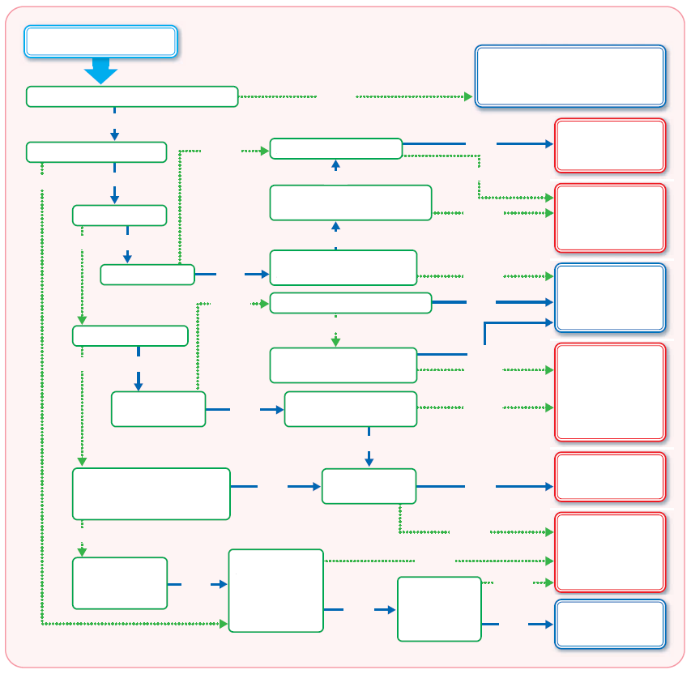

You don’t need to submit anything to Oshu. Submit to the city/town you lived in on Jan. 1, 2018.

Submit a final tax return (kakutei shinkoku)

Submit city/prefectural tax return

No tax return necessary.

Submit a final tax return or a city/prefectural tax return (consult for details)

Submit a final tax return.

Submit city/prefectural tax return

No tax return necessary.

Does that person live in Oshu?

Is someone claiming deductions for you as a dependent family member?

Any untaxable income like survivor`s pension, disability pension?

Any income from a business, farming, other misc. income (real estate, dividends, other temporary income, capital gains, etc.)?

Is your income higher than your deductions?

More than 200,000 yen in income besides public pension?

Less than 4,000,000 yen in public pension income and you won’t declare any deductions?

Does your public pension income amount to zero?

Any income besides adjusted salary?

More than 200,000 yen in income besides adjusted salary?

Is your income higher than deductions?

Was your address in Oshu on Jan. 1st, 2018?

Any income besides public pension?

Any public pension income?

Did workplace do year-end adjustment?

Salary income?

Any income in 2017?

**Start**

No

No

Yes

Yes

Yes

Yes

No

No

No

Yes

Yes

No

Yes

No

Yes

No

No

Yes

No

Yes

No

Yes

No

Yes

Yes

Yes

Produced/translated by Oshu City ILC Promotion Division

Yes

Yes

Yes

No

No

No

No