Road Closures for the 2017 Oshu City Kirameki Marathon

A marathon will be held on Sunday, May 21st in Oshu. There will be partial (one land) and full (both lane) road closures along the marathon course. Please see the map and time schedule below.

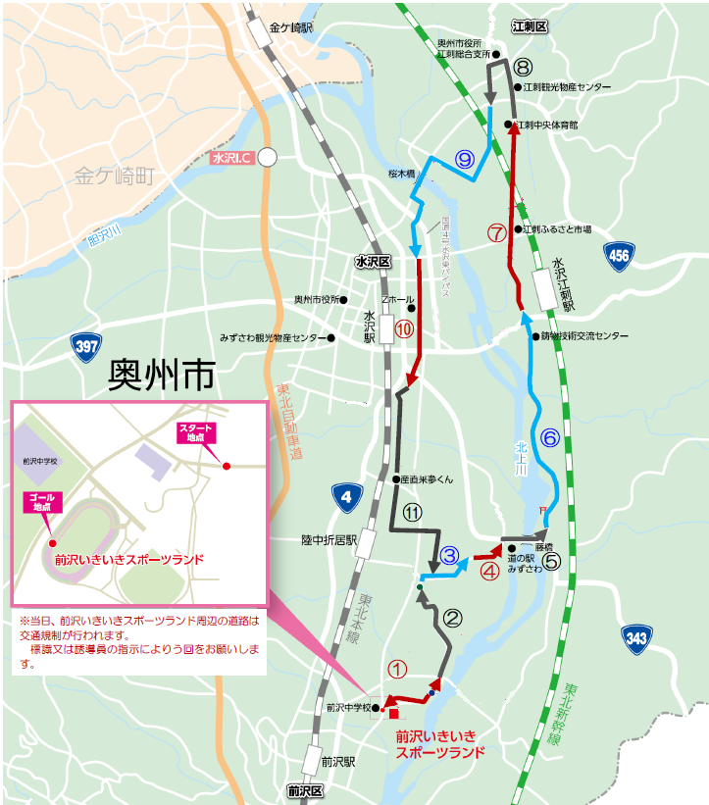

**There will be closures around Maesawa Iki Iki Sportland during the race.**

**Please use detours following signs and staff instructions.**

Shirayama Kita Comm. Center

Omagari Bridge

|  |  |  |
| --- | --- | --- |
| Section | Closed Lanes | Closure Times |
| **①** | Both | 8:00 AM-3:45 PM |
| **②** | Both | 8:15 AM-3:15 PM |
| **③** | Both | 8:15 AM-2:50 PM |
| **④** | Both | 8:15 AM-9:50 AM |
| **⑤** | Both | 8:40 AM-9:50 AM |
| **⑥** | One side | 8:45 AM-10:50 AM |
| **⑦** | One side | 8:55 AM-11:30 AM |
| **⑧** | One side | 9:10 AM-11:50 AM |
| **⑨** | One side | 9:15 AM-12:45 PM |
| **⑩** | One side | 9:35 AM-1:05 PM |
| **⑪** | One side | 9:45 AM-2:50 PM |

Fuji Bridge

**Oshu City**

**Maesawa Iki Iki Sportsland**

Maesawa JR HS

Rikuchuorii

Station

Near Mizusawa Police Station

Tire World

Max Value Esashi

Mizusawa-Esashi Stn.

Mizusawa IC

Maesawa Stn.

Mizusawa Stn.

Kanegasaki Stn.

Esashi Central Gym.